I
n this session we will try to understand what external task is ? and how it works?

External Task

- External task concept was introduced with camunda version 7.4.0.
- The process engine supports two ways of executing service tasks
  - Internal Service tasks: Synchronous invocation of code deployed along with a process application
  - External tasks: Providing a unit of work in a list that can be polled by workers

- Using external (service) tasks, Process engine publishes a unit of work to a worker to fetch and complete. We refer to this as the external task pattern.

Camunda External Task Service
- You can have business logic for external service task implemented locally or remotely. In case of remote business logic, you can use remote call to delegate task to remote system.
- With external service task, camunda does not actively call a service (which would be PUSH), but worker fetch work items queued for them (PULL). Whenever a worker finishes his work item, he reports completion back to Camunda. Workers can use the Java API, but most often leverage the REST API, as this allows to run workers as own process.

Pull and Push

The typical pattern when invoking services is push, which means that the process engine actively issues a service call (or executes a script) via the mechanisms described below. But some use cases call for a pull approach, where external worker threads query the process engine API for external service tasks. They then do the actual work and notify the process engine of works completion.
External service task execution flow

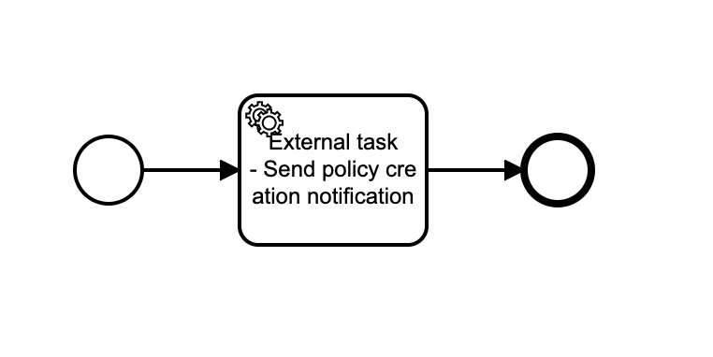
The flow of executing external tasks can be conceptually separated into three steps
Implementation : external
Topic : topicNotificationPolicyCreated
External tasks list
Send notification
Send notification
3. Signal task completed
2. Fetch and lock the tasks
External workers
notification worker
1. Creates an external task instance and adds it to a list of external tasks

- Process Engine: Creation of an external task instance
- External Worker: Fetch and lock external tasks
- External Worker & Process Engine: Complete external task instance

- When the process engine encounters a service task that is configured to be externally handled, it creates an external task instance and adds it to a list of external tasks (step 1).
- The task instance receives a topic that identifies the nature of the work to be performed. At a time in the future, an external worker may fetch and lock tasks for a specific set of topics (step 2).
- To prevent one task being fetched by multiple workers at the same time, a task has a timestamp-based lock that is set when the task is acquired. Only when the lock expires, another worker can fetch the task again. When an external worker has completed the desired work, it can signal the process engine to continue process execution after the service task (step 3).

Benefits of external task pattern

- Crossing System Boundaries: An external worker does not need to run in the same Java process, on the same machine, in the same cluster or even on the same continent as the process engine. All that is required is that it can access the process engine’s API (via REST or Java). Due to the polling pattern, the worker does not need to expose any interface for the process engine to access.
- Crossing Technology Boundaries: An external worker does not need to be implemented in Java. Instead, any technology can be used that is most suitable to perform a work item and that can be used to access the process engine’s API (via REST or Java).
- Specialised Workers: An external worker does not need to be a general purpose application. Each external task instance receives a topic name identifying the nature of the task to perform. Workers can poll tasks for only those topics that they can work on.
- Fine-Grained Scaling: If there is high load concentrated on service task processing, the number of external workers for the respective topics can be scaled out independently of the process engine.
- Independent Maintenance: Workers can be maintained independently of the process engine without breaking operations. For example, if a worker for a specific topic has a downtime (e.g., due to an update), there is no immediate impact on the process engine. Execution of external tasks for such workers degrades gracefully: They are stored in the external task list until the external worker resumes operation.

Exercise:

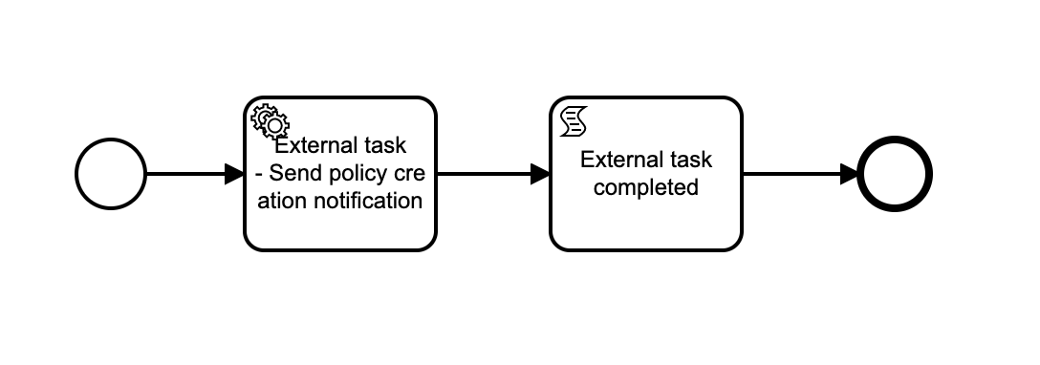
Step 1 : We will model below workflow diagram to demonstrate external task.
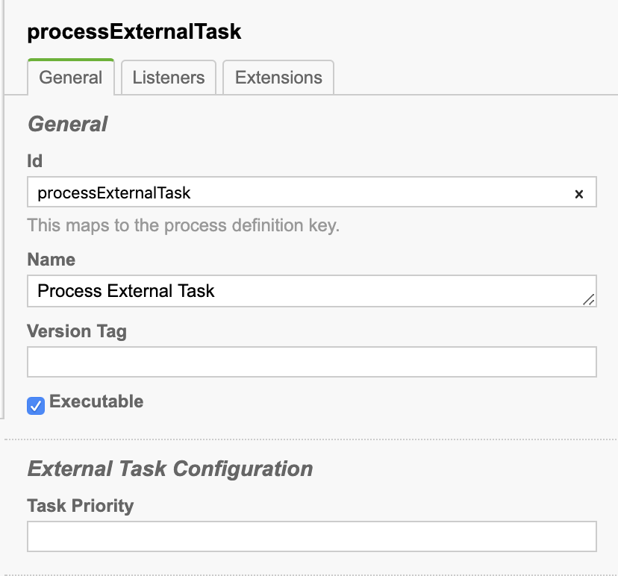
Process Properties:

Id : processExternalTask
Name : Process External Task

Service task properties:

Id : sendNotification
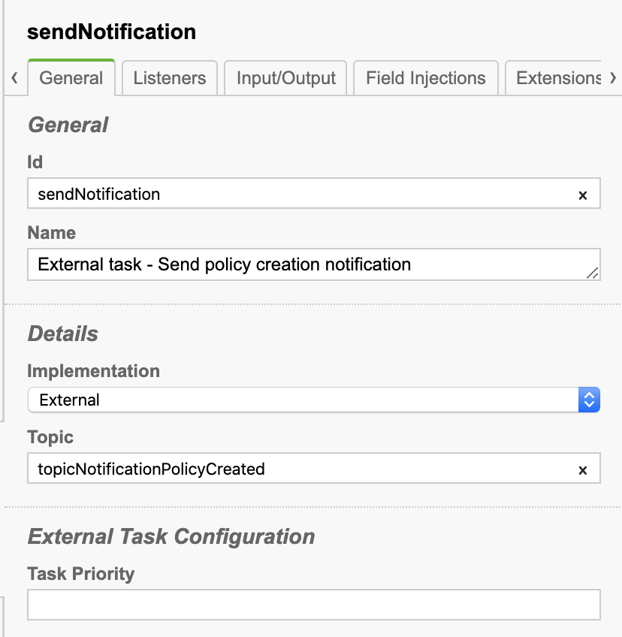
Name : External task - Send policy creation notification
Implementation: External
Topic: topicNotificationPolicyCreated

Script task properties:

Id : scripExternalTaskComplete
Name : External task completed
Script format : groovy
Script type : Inline Script
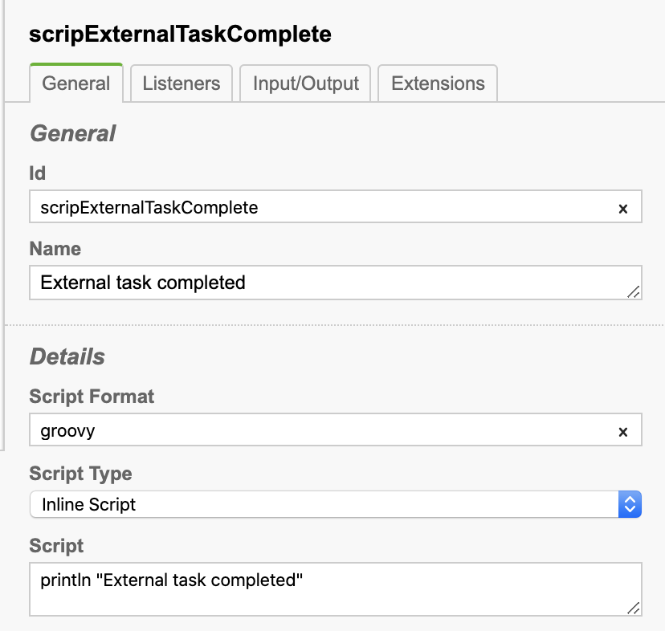
Script : println "External task completed”

Step 2 : Update pom.xml to add groovy engine. Add following dependency to have a groovy script enable for script task.

<!-- https://mvnrepository.com/artifact/org.codehaus.groovy/groovy -->
<dependency>
<groupId>org.codehaus.groovy</groupId>
<artifactId>groovy-all</artifactId>
<version>2.4.4</version>
</dependency>

Step 3 : Implement API to start above modelled process.

package com.camunda.training;

import org.camunda.bpm.engine.RuntimeService;
import org.camunda.bpm.engine.runtime.ProcessInstance;
import org.slf4j.Logger;
import org.slf4j.LoggerFactory;
import org.springframework.beans.factory.annotation.Autowired;
import org.springframework.web.bind.annotation.GetMapping;
import org.springframework.web.bind.annotation.RestController;

@RestController
public class ProcessController {
private static final Logger LOGGER = LoggerFactory.getLogger(ProcessController.class);

@Autowired
private RuntimeService runtimeService;

private static String PROCESS_KEY = "processExternalTask";

@GetMapping("/start-process")
public void startProcess() {
ProcessInstance processInstance = runtimeService.startProcessInstanceByKey(PROCESS_KEY);
LOGGER.info("Process started, process instance : {}", processInstance.getId());
}

}

Step 4 : Implement external worker as scheduler which will pull the tasks from external task list and complete these tasks and notify the process engine of completion of tasks.
package com.camunda.training.worker;

import java.util.List;

import org.camunda.bpm.engine.ExternalTaskService;
import org.camunda.bpm.engine.externaltask.LockedExternalTask;
import org.slf4j.Logger;
import org.slf4j.LoggerFactory;
import org.springframework.beans.factory.annotation.Autowired;
import org.springframework.scheduling.annotation.Scheduled;
import org.springframework.stereotype.Component;

@Component
public class ExternalWorker {
private static final Logger LOGGER = LoggerFactory.getLogger(ExternalWorker.class);

@Autowired
private ExternalTaskService externalTaskService;

private static String EXTERNAL_WORKER_ID = "Process_External_Task";
private static String EXTERNAL_TASK_TOPIC = "topicNotificationPolicyCreated";

@Scheduled(fixedRate = 3000)
public void fetchExternalTask() throws InterruptedException {
List<LockedExternalTask> lockedExternalTaskTasks = externalTaskService.fetchAndLock(1, EXTERNAL_WORKER_ID)
.topic(EXTERNAL_TASK_TOPIC, 2000).execute();
LOGGER.info("{} external tasks locked", lockedExternalTaskTasks.size());
// do the work
for (LockedExternalTask lockedTask : lockedExternalTaskTasks) {
Thread.sleep(5000);

// work on task for that topic
LOGGER.info("Completing task : {}", lockedTask.getWorkerId());
externalTaskService.complete(lockedTask.getId(), EXTERNAL_WORKER_ID, null);

}
}
}

Step 5 : Start the process through rest end point
GET : http://localhost:8081/start-process
Check console output:
2020-07-30 09:52:36.892 INFO 3030 --- [nio-8081-exec-1] com.camunda.training.ProcessController : Process started, process instance : 4601
2020-07-30 09:52:37.446 INFO 3030 --- [ scheduling-1] c.c.training.worker.ExternalWorker : 1 external tasks locked
2020-07-30 09:52:42.451 INFO 3030 --- [ scheduling-1] c.c.training.worker.ExternalWorker : Completing task : Process_External_Task
External task completed

Remote external worker
If your external worker is remote system(implemented in java, .net etc) then we can use Camunda REST API to fetch and lock external tasks and complete.

package com.camunda.training.worker;

import java.io.IOException;

import org.slf4j.Logger;
import org.slf4j.LoggerFactory;
import org.springframework.http.HttpEntity;
import org.springframework.http.HttpHeaders;
import org.springframework.http.MediaType;
import org.springframework.http.ResponseEntity;
import org.springframework.scheduling.annotation.Scheduled;
import org.springframework.stereotype.Component;
import org.springframework.web.client.RestTemplate;

import com.fasterxml.jackson.databind.JsonNode;
import com.fasterxml.jackson.databind.ObjectMapper;
import com.fasterxml.jackson.databind.node.ArrayNode;
import com.fasterxml.jackson.databind.node.ObjectNode;

@Component
public class ExternalWorkerRestAPI {
private static final Logger LOGGER = LoggerFactory.getLogger(ExternalWorker.class);

private static String PROCESS_ENGINE_REST_END_POINT = "http://localhost:8081/engine-rest";
private static String EXTERNAL_WORKER_ID = "Remote_External_Task_Worker";
private static String EXTERNAL_TASK_TOPIC = "topicNotificationPolicyCreated";

@Scheduled(fixedRate = 30000)
public void fetchExternalTask() throws IOException, InterruptedException {
LOGGER.info("Fetching, locking and completing external tasks from remote system");

final ObjectMapper mapper = new ObjectMapper();

final ObjectNode topic = mapper.createObjectNode();
topic.put("topicName", EXTERNAL_TASK_TOPIC);
topic.put("lockDuration", 2000);

final ArrayNode topics = mapper.createArrayNode();
topics.add(topic);

final ObjectNode root = mapper.createObjectNode();
root.put("workerId", EXTERNAL_WORKER_ID);
root.put("maxTasks", 1);
root.set("topics", topics);

HttpHeaders headers = new HttpHeaders();
headers.setContentType(MediaType.APPLICATION_JSON);

// fetch and lock 3 tasks for 5 minutes
HttpEntity<String> entity = new HttpEntity<String>(//
mapper.writeValueAsString(root), // here is the JSON body
headers);
String result = new RestTemplate().postForObject(PROCESS_ENGINE_REST_END_POINT+"/external-task/fetchAndLock",
entity, String.class);

JsonNode answer = mapper.readTree(result);

for (JsonNode lockedTask : answer) {
String taskId = lockedTask.get("id").asText();
// Do some work
double random = Math.random();
long duration = (long) (random * 5000);

LOGGER.info("work on task {} for {} milliseconds", taskId, duration);
Thread.sleep(5000);

LOGGER.info("complete task {}", taskId);
ObjectNode resultVariable = mapper.createObjectNode();
resultVariable.put("value", duration);
ObjectNode variables = mapper.createObjectNode();
variables.set("calculated value", resultVariable);
ObjectNode completeRoot = mapper.createObjectNode();
completeRoot.put("workerId", EXTERNAL_WORKER_ID);
completeRoot.set("variables", variables);

entity = new HttpEntity<String>(mapper.writeValueAsString(completeRoot), headers);
ResponseEntity<Object> completeResponse = new RestTemplate().postForEntity(
PROCESS_ENGINE_REST_END_POINT+"/external-task/" + taskId + "/complete", entity, null);

LOGGER.info("External task {} completed", taskId);

}

}
}

External task client
package com.camunda.training.worker;

import java.util.Map;

import org.camunda.bpm.client.ExternalTaskClient;
import org.slf4j.Logger;
import org.slf4j.LoggerFactory;

public class ExternalClient {
private static final Logger LOGGER = LoggerFactory.getLogger(ExternalWorker.class);

private static String PROCESS_ENGINE_REST_END_POINT = "http://localhost:8081/engine-rest";
private static String TASK_TOPIC = "topicNotificationPolicyCreated";

public static void main(String... args) {
// bootstrap the client
ExternalTaskClient client = ExternalTaskClient.create().baseUrl(PROCESS_ENGINE_REST_END_POINT).build();

// subscribe to the topic
client.subscribe(TASK_TOPIC).lockDuration(1000).handler((externalTask, externalTaskService) -> {
Map<String, Object> taskVariables = new java.util.HashMap<>();
taskVariables.put("finalAmount", 1000);
// complete the external task
externalTaskService.complete(externalTask, taskVariables);

LOGGER.info("The External Task : {} has been completed!", externalTask.getId());

}).open();
}
}

